|  |  |  |  |  |  |  |  |
| --- | --- | --- | --- | --- | --- | --- | --- |
|  | |  | | --- | | ISIS practice  For BT people | | EPT/OHP/B037 | | Issue 14, 26-Mar-2014  Use until 26-Mar-2021 | | Published by Technical Documentation - Openreach | | Privacy- Internal | | |
| Poling Handbook - Manual Poling - Provision | |  |
|  | |  |

About this document ...

If you do not want to receive future updates of this document, please de-register by sending your name, address, and OUC to the ISIS Helpdesk (01206 894088).

Author

The author of this document may be contacted at:

|  |
| --- |
| ISIS co-ordinator . |
| ISIS co-ordinator |
| Openreach Network Engineer's Office () |
| Post Point .  .  .  .  .  . |
|  |
| Telephone: . |
| Fax: |
| Email: aei.doc.control@bt.com |

Content approval

|  |
| --- |
| This is the Issue 14 of this document. |
| The information contained in this document was approved on 26-Mar-2014 by Glen Barford, In - Life Access Engineering Manager - Overhead Networks |

**Version History**

|  |  |  |  |
| --- | --- | --- | --- |
| Version No. | Date | Author | Comments |
| Issue 14 | 03-Mar-2015 | Document Manager T | Document migrated onto new platform with no content change |
| Issue 14 | 26-Mar-2014 | ISIS co-ordinator . | hessian sack provider details updated (AT306) |
| Issue 13 | 9-Jan-2014 | ISIS co-ordinator . | CGA/N207 - Handling and Examination of Creosoted Pole (in SFY/HSH/C009) referenced to in sections 1.3.3 and 8 (AT) |
| Issue 12 | 6-Jan-2014 | ISIS co-ordinator . | SFY/ESP/C026 references updated to SFY/HSH/D057 (AT280) |
| Issue 11 | 30-May-2012 | Chief Engineer's Office Technical Documentation Team | Document reviewed.Section 4.4.4. revised to include reference to 7 metre Medium poles. (DCC101PD) |
| Issue 10 | 4-Nov-2010 | Chief Engineer's Office Technical Documentation Team | Section 4.4.2. updated. DCC1062/SH. |
| Issue 9 | 6-Oct-2010 | Chief Engineer's Office Technical Documentation team | Document reviewed.Para. 1.3.1 revised. (Integration EM 5-2009)Para. 3.1 revised. (Integration EM 5-2009)(DCC1002PD) |
| Issue 8 | 26-Feb-2010 | Chief Engineer AEI Technical Documentation team | Document reviewed.Para 6 revised. (DCC600) |
| Issue 7 | 3-Feb-2009 | Chief Engineer AEI Technical Documentation Team | Minor text amendment to section 6 |
| Issue 6 | 30-Dec-2008 | Chief Engineer AEI Technical Documentation Team | Inclusion of new section on leaning poles and change of author & approver |
| Issue 5 | 22-Aug-2007 | Keri Thomas | Changes to Hand Digging Practices in Section 3.6 |
| Issue 4 | 12-Mar-2007 | Keri Thomas | Updated to reflect changes in Para 5.5 (Backfilling) plus inclusion of new range of reference material |
| Issue 3 | 14-Apr-2005 | Keri Thomas | Change of Approver |
| Issue 2 | 8-Apr-2005 | Keri Thomas | Change of author and approver |
| Issue 1 | 30-Apr-2003 | Nick Adams | First issue of new document -part of poling handbook |
| Issue Draft 0b | 26-Jun-2002 | Nick Adams | Draft 0b -26-June-2002 comments from Field & Training included |
| Issue Draft 0a | 23-May-2002 | Nick Adams | First draft- new poling handbook May 2002 |
|  |  |  |  |

Table of Content

1 Introduction 5

1.1 Scope 5

1.2 Training 5

1.3 Safety 5

1.4 Manpower Requirements 8

2 Handling of Poles 8

2.1 General Principles 8

2.2 Pole Stacks 9

2.3 Carrying Poles 13

2.4 Mechanised Lifting 20

2.5 Transportation by Vehicles without Cranes 20

3 Excavations for Pole Holes 25

3.1 Checking for Other Services 25

3.2 Depth of Hole 25

3.3 Banks/slopes 25

3.4 Rock 25

3.5 Manual Excavation 25

3.6 Digging the Hole 26

3.7 Blasting 28

3.8 Cylindrical Holes 29

3.9 Stepped Holes 29

4 Erecting the Pole 30

4.1 Manpower 30

4.2 Equipment 31

4.3 Pole Hole Preparation 32

4.4 Methods Used 33

5 After Pole Erection 43

5.1 Supporting Pole after Erection 43

5.2 Pole Orientation 44

5.3 Twisting 44

5.4 Setting the Pole 45

5.5 Backfilling 46

5.6 Filling Cylindrical Holes 46

5.7 Hollow Pole Sealing 47

6 Method for Dealing with Leaning Poles 47

7 Tools and Equipment Lists 48

8 References 50

9 Risk Assessment 50

# Introduction

This document describes the methods, equipment and plant to be used for erecting poles with the exception of the use of mechanised units. The use of these units is covered in EPT/OHP/B034.

This document should be read in Conjunction with EPT/ANS/A010 - Specification for Poling Work and EPT/OHP/B036 - Pole Fittings and General Furniture.

As a general principal avoid the manual handling and erection of poles wherever possible - use mechanised methods. Manual methods should only be used as a last resort.

Where manual handling is unavoidable always use correct handling and lifting techniques refer to the Health & Safety Handbook and the methods described in this ISIS. Ensure that everybody involved in the task is trained in the techniques to be used.

## Scope

The contents of this document cover all aspects of erecting the pole, which are not carried out by mechanised methods. Refer to the index document, EPT/OHP/B033 for details of other aspects of poling.

It covers the transportation and erection of poles by manual methods.

## Training

Any person carrying out or assisting in the operations described in this ISIS must have been trained in the appropriate practice.

Where there is any practice carried out which is not covered by these instructions then that practice should conform to other existing documented and trained practices.

Where the manual lifting or erection of poles is being carried out, it is important that all the people involved are capable of working together as a team using the methods in this document.

## Safety

These SAFETY notes are for all concerned with manual poling, and the general public - please read them.

### Operational Safety

1. Establish who is in charge of operations before any work commences and keep this arrangement in place throughout the task.
2. Ensure you have a clear system of communications for the task in hand.
3. Always wear the appropriate safety clothing and equipment detailed in safety ISIS, and the Health & Safety Handbook.
4. Roadwork Guarding should be carried out as described in the current Code of Practice for Streetworks documentation.
5. Always observe general safe lifting and handling practices.
6. Do not use metal, GRP or light wooden ladders to erect poles. Use only stout wooden ladders and remember to provide an adequate number of guy lines for steadying purposes.
7. Never climb, or let anyone else climb, a pole in course of erection. Wait until the pole is properly set in the ground with all of the backfill rammed down. This applies to work from a ladder or the pole itself.
8. Where a pole is supported on a pole horse and there is any risk of it rolling, falling or being knocked off, do not leave it unattended.
9. Wood poles are a natural product, and because of the variability in size of the trees from which they are produced sizes and weights will vary considerably. (Specifications define minimum sizes to achieve specific strength. Absolute maximum weights are also specified.) Whenever poles are to be manually handled or erected, smaller poles in the class and of the length required should be selected. This should ensure that weights are no more than the average figures given in EPT/OHP/B058. It is strongly recommended that heavier poles or Southern Yellow Pine poles (3m mark ‘Z’) should not be manually handled or erected. Where this is unavoidable appropriate numbers of extra people should be used in the exercise.
10. During manual pole handling and erection, teamwork is essential. Poor teamwork or misinterpreted instructions can leave one person taking an unsustainable load with the consequence of serious injury. However, it is essential that ONLY one person is in charge, and issues instructions to the team. Ensure that everyone understands what is about to happen when any command or order is given. Any command must be clear. Be especially careful when a new person joins an established team. You may know exactly what is about to happen, they may not.
11. The work site must be adequately guarded to ensure that unauthorised persons are kept clear of the work area. It is particularly important that where a possibility exists of a pole becoming unstable, that the work area is kept clear.
12. Ensure that work will be sufficiently clear of any overhead obstructions or hazards during operations, particularly power lines. Separation distances are referred to in Health & Safety Handbook, EPT/PPS/B026 and EPT/PPS/B046.
13. You should always check for buried services before any excavation takes place. Remember pole erection activities should normally be considered as planned work, and the safe digging procedures referred to in ISIS document SFY/HSH/D057 should be used. See also ISIS EPT/OHP/B034 EPT/OHP/B035
14. Where there is any chance of a load falling whilst it is being carried or lifted by a group of people, ensure that there is an agreed safety side, and where possible all those involved should work from that side. This will enable everyone to move clear if the pole should be dropped.
15. Have a clear agreed signal for dropping the load in an emergency.

### Safety Checks

Ensure that all the necessary formal safety checks have been carried out on your equipment. In addition ensure that you have checked the equipment before use and that you are confident it is safe to use and not damaged. Look particularly at the equipment for lifting and handling poles, for example ropes, pole grabs, stout ladders, Sheerlegs etc.

### Creosote

1. All wooden poles are currently impregnated under pressure with 100% coal tar creosote. Any risks and precautions of handling creosote treated timber or the creosote itself are covered in the BT COSHH assessment for the work concerned, [CGA/N207](http://documents.intra.bt.com:83/edrsbks/i_sfyhsh/books/1hshc009/extfile/cgan207.doc) - Handling and Examination of Creosoted Pole (in SFY/HSH/C009 ) and the precautions outlined in this should be adhered to.

For normal dry poles standard protective equipment should be worn.

Poles are seasoned and treated so as to reduce the probability of creosote ‘bleeding’ out to a minimum; however a small percentage of poles will bleed. Where poles are bleeding significantly and have not been installed they should not be used. Poles will occasionally bleed in situ, and where these have to be handled or climbed avoid getting the creosote on your skin as far as possible by wearing protective clothing. If the clothing gets contaminated with creosote such that it is likely to come through the clothing or gloves, change the protective clothing. It is advisable to carry spare protective clothing.

Exceptionally, if a pole is wet with creosote is to be manually handled, use Hessian or, other suitable cloth to absorb the creosote and/or wrap the pole where it would come into contact with personnel. Further details on Bleeding Poles are covered in ISIS EPT/ANS/A010.

Other preservative treatments have occasionally been used within BT, but only very small numbers of poles having these alternative treatments are in use in BT. Poles having such treatments can be identified by the three metre mark (see EPT/OHP/B058).

## Manpower Requirements

The manpower used for pole handling and pole erection will be different for virtually every circumstance, and will depend upon the vehicle location, the pole site and how the pole will be transported between the two. The method of pole erection will also determine the numbers of people required.

Pole weights are documented in ISIS EPT/OHP/B058. Lighter poles should be picked wherever possible for manual work.

The Risk Assessment at Section 8 of this document should also be consulted to help determine the numbers of people required.

# Handling of Poles

## General Principles

Details for dressing poles are covered in EPT/OHP/B036.

The use of a lorry mounted crane/PEU to handle, transport and erect poles as much as possible should always be a priority. Manual handling should be a last resort.

Crane type pole timber grabs reduce the need to climb onto pole stacks where a number of poles have to be moved. The use of hand type pole timber grabs and pole trucks can minimise direct contact with poles which are wet with creosote and also help with manual handling.

The person in charge must always ensure that there are sufficient people to handle the pole(s), being dealt with, and grade the party in terms of height to ensure the even distribution of weight if a pole is shouldered.

When handling or moving wooden poles, if possible avoid letting them fall or drop onto the ground or other hard surface particularly butt first. If a pole is dropped it can suffer serious structural damage. If you have a pole which has been dropped either from a pole stack, vehicle or while it was being carried do not erect it. Put it to one side and inform your manager. It must be checked by a Pole Examiner before using it.

Always distribute the available people along the pole in proportion to the pole weight.

## Pole Stacks

Avoid climbing on pole stacks. When this is unavoidable be sure that those underfoot are properly wedged or otherwise secured.

Be especially careful where there are loose battens placed between the layers of the poles as this can make the poles particularly unstable.

Where the pole has to be manually lifted to position a sling etc, lift the tip of the pole where possible. Ensure that there are sufficient people available to lift the pole end. Use suitable crow bar(s) or digging bar(s) to lift the pole end and place a chock or support (digging bar or batten) under the pole to keep it in the raised position (see Figure 1). If necessary use Timber Grabs to raise the pole end.

When positioning the sling or pulling rope - do not pass your hand(s) under the pole.

Figure 1: Pole Chocked to Allow Safe Fitting of Lifting Sling/rope



### Temporary Stacks

If poles are stacked away from a BT pole stack during poling operations, it should be ensured that the stack is sufficiently secure for the purpose to which the stack is being put. As a minimum the outer poles of the bottom layer should be secured to prevent the stack collapsing or moving.

If the stack is not on BT property, wherever possible only have a single layer of poles and if the stack is to be left unattended all the poles should be secured together and to a suitable fixed object to prevent them rolling or being rolled. If there is more than one layer of poles the bottom layer should be secured to prevent the stack collapsing.

### Taking Poles off a Pole Stack Manually

Where exceptionally a pole has to be manually removed from a pole stack use the following method:

Only remove a pole from the top of the stack, and whenever possible remove it butt first (it may not be possible to drag the pole off tip first). Never remove a pole from a stack which is above mid chest height for the staff lifting the butt end of the pole, as the lift will be too high. This is because the pole will adopt a steep angle during the operation which may make it difficult to stop the pole sliding.

You should have sufficient people to carry the pole using Timber Grabs to carry out this operation (see EPT/OHP/B058 for pole weights). An even number of people are required.

The person in charge of the operation should stand to one side of the pole/stack, sufficiently clear that he will not be in danger if the pole falls, but in a position to give clear orders to the rest of the team until the pole is almost off the stack.

Secure a pulling rope to the pole using a timber hitch (having first lifted and chocked the pole if necessary) (see Figure 2). On command, the party gently pull the pole off the stack to before the balance point (approximately the position of the Three Metre mark); ensuring the pole does not become unbalanced.

Figure 2: Pulling Pole off Stack (1)

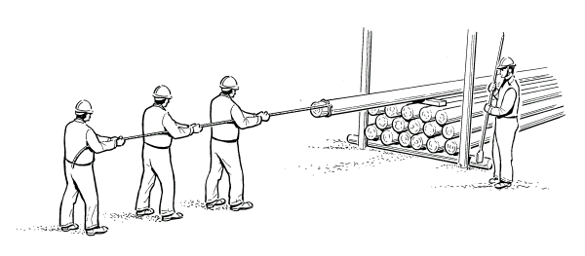

The front two people should now drop out of the pulling team and hold the pole at the end, just behind the rope using a Timber Grab (see Figure 3).

Figure 3: Timber Grab Hand Type

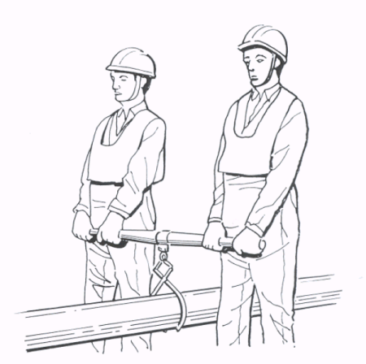

On command the pole should again be pulled slowly forward until there is weight on the butt end of the pole, supported by the people with the lifter. Stop pulling when the weight is sufficient for the pole to be lowered to the ground. DO NOT pull too far as this can place excessive strain on those holding the pole.

Lower the end of the pole to the ground.

The next two people should now come from the pulling party to lift the pole behind the first two using another set of Timber Grabs.

On command the pole should be lifted by all four people and again it should be pulled forward and stopped on command before the load becomes excessive for those taking the weight. This process should be repeated until there is only one person pulling. At this stage lower the pole, and remove the rope. Lift the pole and on command slide it until only the tip of the pole is supported. Be very careful not to slide the tip of the pole off the stack. Lower the pole.

The last person pulling and the person in charge should now take the last lifter to the tip of the pole. At this stage, if necessary redistribute the people ready to lift the pole clear of the stack (see Figure 4).

Lift the pole clear.

Figure 4: Pulling Pole off Stack (2)

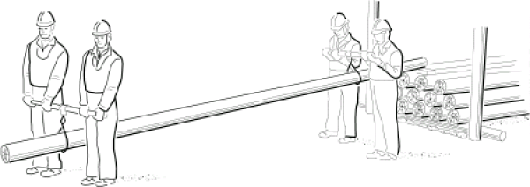

## Carrying Poles

### Wood Poles

Poles should normally be carried using a Trucks Pole Carrying and Timber Grab. If terrain or obstacles prohibit the use of a truck, use the timber grabs or rope method (reference) - if this is not possible, only as a last resort shoulder the pole. If the pole is shouldered take care to keep creosote off the skin.

#### Trucks Pole Carry Method

1. Lift the butt of the pole using Timber Grabs and place a Trucks Pole Carry under the pole.
2. Position the pole on the truck so that the load on the tip is easily supported by two people using a timber grab. Two people lift the tip of the pole using a timber grab. See Figure 5.
3. Tie the pole truck to the pole using the lanyard to ensure the pole does not slip off the truck.
4. If extra effort is required use more timber grabs and pairs of people.

Figure 5: Using a Pole Truck

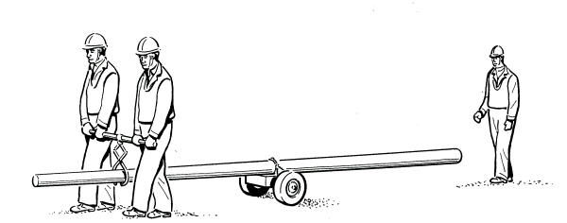

#### Timber Grabs or Rope Method

For cross country work or where members of the party vary greatly in height, use the rope method detailed below:

(a) Lay out a zig zag of rope down one side of the pole (see Figure 6). The rope length (approximately twice the length of the pole) and number of loops should suit the number of people. Roll the pole onto the rope and secure the rope ends using a clove hitch locked off with a half hitch. Use the rope loops, equally spaced, as carrying handles (see Figure 7).

(b) Alternatively use timber grabs as shown in Figure 3.

Figure 6 Preparation for Rope Carry

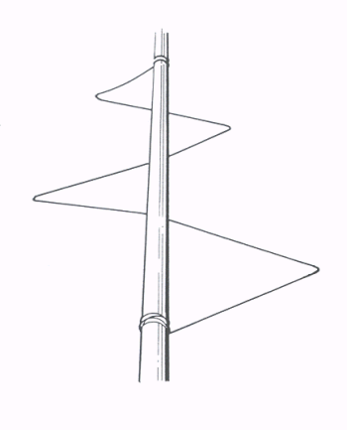

Figure 7: Carrying Pole Using Rope

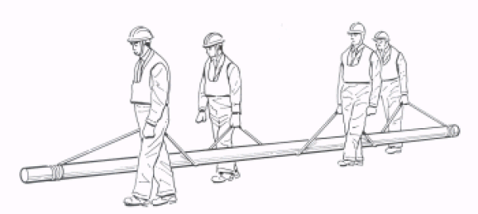

#### Shouldering the Pole

Prior to shouldering the pole, the person in charge of the operation should ensure that people involved in the operation are graded in height, and they pick the pole up and carry it keeping the height order.

1. The pair nearest the tip (one positioned either side) prepares to lift the tip with shoulders locked as shown. Do not lock your fingers below the pole (see Figure 8).

Figure 8: Preparing to Lift Pole Tip

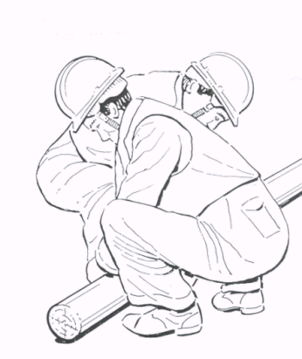

2. The rest of the party should assist in lifting the tip.

3. Raise the tip onto the front pair’s shoulder(s), ensuring that the butt is left on the ground (see Figure 9).

Figure 9: Pole Tip Shouldered

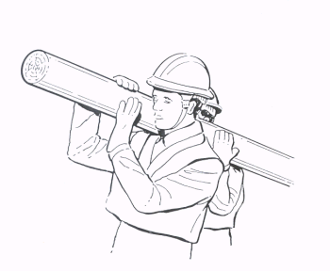

4. Once the tip is secure, reposition to maximise effort at the butt and raise the butt onto the shoulders of the remainder of the party. The front pair should now adjust their position to the same side of the pole.

5. All people must now be on the same side of the pole for a shouldered carry.

6. Adjust the position one by one along the length of the pole to ensure even support before moving off (see Figure 10).

Figure 10: Pole Ready to Carry

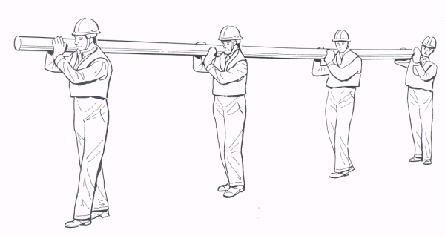

To lower the pole:

Lower first to arm level then butt first to the ground. Do not throw it off the shoulders (see Figure 11).

Figure 11: Lowering Pole

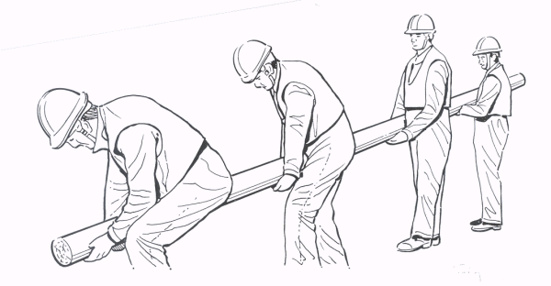

REMEMBER

Protect your skin from creosote.

* A pole must always be shouldered and lowered with all people on the same side - so that the pole can be dropped clear in an emergency. Ensure that no-one walks into the area where the pole may be dropped.
* In the event of an emergency give a clear shout to drop the pole clear to avoid anyone not realising and being left taking the weight of the pole. Do not try to save the pole from falling. If this occurs, the pole must not be installed. It should be returned to the depot for inspection by a Pole Examiner, see Section 2.1 above.

1. A padded protective Over Jacket is available for use by Pole Erectors. The Poling Jacket provides protection to the shoulder & neck areas and is particularly useful when manually erecting Poles. See Corporate Clothing Catalogue for further details.

### Hollow Poles

Hollow poles may be manually lifted and carried by any of the appropriate means in the sections above, except, obviously, those involving timber grabs.

Always remember that although hollow poles are light, their thin sections can cause severe injury if you are caught between the pole and any other object. Always wear gloves leather when handling hollow poles and be careful not to get your hand or fingers trapped.

## Mechanised Lifting

Mechanised lifting and handling of poles should be carried out as described in EPT/OHP/B034, Mechanised Poling Operations.

## Transportation by Vehicles without Cranes

Wherever possible, manual handling should be avoided, and a vehicle without a crane should only be used to transport poles as a last resort. If it is essential, whenever possible a crane vehicle or other crane/gantry should be used to load the pole.

When loaded, the pole should always be stowed tip forward.

Poles must only be carried between bolsters or other suitable side supports or within the vehicle. Poles should be adequately secured.

When loading hollow poles, protect the outer coating from metal or sharp edges using sacking, wooden battens or lengths of plastic ducts. The battens or duct should be secure. If duct is used then duct 56, 102 or sub duct should be placed over the pole bolsters/support and slit or sectioned duct should be placed over the area the poles will rest on.

Do not mix hollow poles and wood poles in the same space without protecting the surface of the hollow pole.

### Vehicle Loading Limitations

The maximum number of poles that may be carried on any vehicle should be limited by:

1. No poles shall be above the bolsters or side support (that is the centre line of the top pole should be below the tip of the lowest bolster/support retaining the pole).
2. The sum of the weight of the poles and the unladen weight of the vehicle plus the weight of any stores carried shall not exceed the gross weight of the vehicle. Refer to vehicle plate and handbook. If in doubt have vehicle weighed with full complement of stores and tools. (Pole weights will be found in ISIS EPT/OHP/B058
3. You should be within any limits for off centre loading as shown in the vehicle manufacturer’s handbook (if any).

### Loading and Unloading Poles from Vehicles Manually

(a) Do Not attempt to load poles manually into vehicles where the lift is above shoulder height.

(b) At the rear of the vehicle, shoulder the tip as if for manual carrying. Raise the butt to approximately waist height (see Figure 12).

Figure 12: Loading Pole onto Vehicle (1)

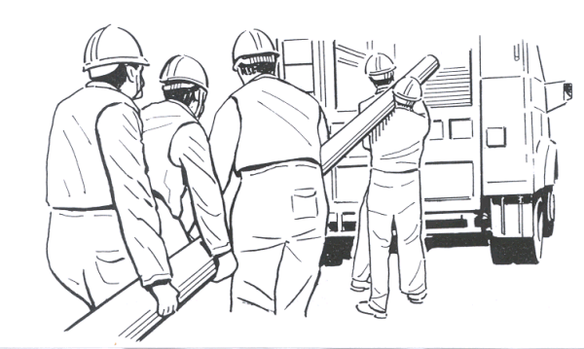

(c) Move forward. Support the tip on the rear bolster/tail lift or the rear of the vehicle. Advance it well forward into the vehicle body. Ground the butt temporarily.

(d) Sufficient people enter the vehicle body to support and guide the tip. Raise the butt again and feed the pole forward into the carrying position (see Figure 13). Use the Tail lift or any other strong section across the back of the vehicle to support the weight of the pole as much as possible.

Figure 13: Loading Pole onto Vehicle (2)

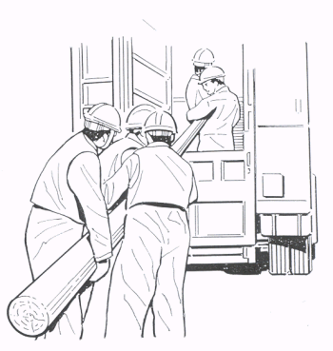

Unloading of poles from a vehicle is a reversal of the loading process.

### Positioning of Poles on Vehicles

The regulations governing the carrying and marking of overhanging loads during the day or night must be adhered to.

Check with the Drivers Handbook MTT/VHE/E001 or BT Motor Transport for confirmation of current requirements as they relate to your vehicle.

Poles should be positioned so as to minimise overhang.

Check the height of the vehicle/load if poles which have been loaded extend above the normal transport height of the vehicle.

Special rules may apply locally, for example London - ensure you know these.

You should illuminate overhangs and signs at night in accordance with the Drivers Handbook.

### Securing Poles

When loaded, poles must be secured to the vehicle in a safe manner.

Poles should normally be secured using straps and tensioners (see Figure 14). Use:

1. Tensioner 3A Ratchet Tensioner for use with straps tensioning has short length of webbing attached with a snap hook to attach it to a securing eye or strong point on the vehicle.
2. Strap Tensioning 1A, 3m A 3m long strap with a snap hook on one end.
3. Strap Tensioning 2A, 9m A 9m long strap with a D buckle on one end.

If necessary use a suitable shackle to attach the strap tensioning to a lashing point, or in the case of the Strap Tensioning 2A pass the strap through the lashing point on the vehicle and then loop the strap back through the D buckle.

Figure 14: Secure Pole with Straps Tensioning

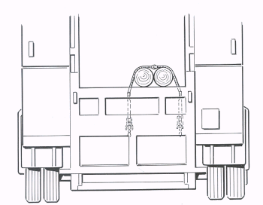

If suitable lashing points to use the Straps Tensioning are not available wood poles may be secured using a suitable strong point and rope. In this case the rope should be secured to the pole with a staple (see Figure 15).

Figure 15: Securing With Rope and Staple

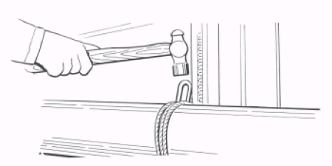

Unsecured hollow poles, particularly the very smooth GRP ones, tend to vibrate off the vehicle even when it is stationary. Hollow poles can even slip through the lashings. It is recommended that hollow poles are secured with a Hooks Aerial Cable No. 1 hooked under the butt or the cable entry holes and secured to the vehicle with a loop of Drawrope No. 1

The same procedure is not necessary for wood poles, but they should not be left unsecured for longer than absolutely necessary as they can vibrate down the unit if left unsecured whilst the vehicle is running.

All poles should be secured using straps at the tip and at the butt. If the tip is contained within an enclosed aperture within the vehicle then further securing of the tip is not necessary.

Only use the correct lashing points for securing the poles, do not use the ‘tarpaulin hooks’ found down the sides of some vehicles.

Poles must be lashed so that there is no chance of them sliding off the vehicle under braking, acceleration or cornering.

The lashing at the rear of the unit should ensure that the poles are secured together by a turn around all the poles in each ‘bay’, and that the poles are pulled down onto the pole supports. Where there are three or more poles in one bay it should be ensured that all the poles are secured together so that poles cannot be ‘loose’ in the centre of the bay. This may mean having separate lashings for some poles in a bay.

Always check and re-tension the lashings after a short distance to ensure they have not come loose (the poles tend to ‘bed’ down and slacken the lashings).

Care should be taken to ensure that all loose ends of webbing are securely contained on the vehicle before driving off.

# Excavations for Pole Holes

## Checking for Other Services

Before excavating manually you must have carried out the requirements of Safe Digging practices. Ensure you have searched thoroughly for the presence of any buried services. Investigate each proposed pole/strut/stay/ temporary anchor position, using the procedure described in ISIS SFY/HSH/D057 and the Health & Safety Handbook.

NB: Wherever excavations for poles or stays are to be undertaken using mechanical means, a mandatory 3 part risk assessment must be carried out prior to any work in order to determine the appropriate method of excavation / installation. The risk assessment process is fully detailed in ISIS EPT/OHP/B034 (Poles) and EPT/OHP/B035 (Stays).

## Depth of Hole

Refer to ISIS EPT/ANS/A010 for the planting depths of poles.

## Banks/slopes

Increased depths must also be allowed where poles are set in banks, since there would be a liability of the side of the bank giving way under heavy stresses. Full details are covered in ISIS EPT/ANS/A010.

## Rock

Poles set in rock sockets and in stable rock backfilled excavations may have adequate and safe stability when the depth is as little as 0.9m (that is 2.1m between the ground line and the three metre mark). Refer to EPT/ANS/A010 for guidance on determining whether a rock socket can apply, and other conditions.

## Manual Excavation

All excavation and reinstatement should be in accordance with ISIS EPT/UGP/B053, and comply with the New Roads and Streetwork Act.

Always follow the rules for safe excavation, see ISIS SFY/HSH/D057.

## Digging the Hole

### Tools / Equipment

The following range of specialised hand digging equipment is available for this task.

* Spade Rabbiting - Item Code 116543: Traditional steel product used for excavating Pole holes.
* Spade Rabbiting GRP - Item Code 129492: Similar to the steel rabbiter, but with a GRP Shaft which can be lengthened (where required) using an Extension Shaft.
* Extension Shaft GRP - Item Code 129474:A 600mm long extension shaft for use with the Rabbiter GRP.
* Spoon Excavating GRP - Item Code 129471:Used to remove loose spoil from pole holes.
* Punner - Curved for Poling - Item Code 129472: A ‘crescent shaped’ punner, with a GRP Shaft. This tool is specially designed for reinstating spoil around the Pole. The radius is matched to standard pole sizes.
* Digging Bar - GRP Handle - Item Code 129473: A digging bar, which has the weight concentrated in the chisel end. This tool is particularly useful for breaking out tarmac etc around the foot of a pole, although it can be used for any digging application.

Scissor Action Holing Shovels - Local Purchase: Although these items are not supplied as standard stores items, they may be used as an alternative to the tools shown above.

1. Managers of Operational teams wishing to purchase / use Holing Shovels, or similar alternative products, must ensure that a formal risk assessment is undertaken by Accenture Safety Services before such tools are employed.

Figure 16: Openreach Specialised Digging Equipment



### Using the Tools

(a) Excavate top soil to a depth of 450mm using a Digging Bar GRP and Spade.

(b) Use the Rabbiter to loosen and lever away the soil. This should loosen ordinary soil sufficiently to enable it to be removed.

1. If a Steel Rabbiter is used for this exercise, the tool should be used in a throwing action and be allowed to fall under its own weight.

(c) When digging at depth the Extension Shaft GRP can be attached to the Rabbiter GRP to provide extended reach into the hole. This will also enable a more comfortable working posture to be maintained. See Figure 17

(d) Remove loosened soil with the Spoon by gathering the material in a circular motion and lifting. The GRP Spoon may be levered moderately against the side of the hole to remove soil. However, care should be taken to ensure that not too much leverage is applied as this may result in the shaft slipping from the grip.

1. Where traditional wooden spoons are being used, leverage must not be applied, as this may cause the handle of the spoon to break.

(e) On reaching the required depth, thoroughly pun the bottom of the hole with a punner to ensure that the pole stands on firm soil.

1. 1. Remember to keep whatever activity you are undertaking within task. DO NOT OVERSTRETCH YOURSELF.

2. Apply moderate force only when using any tool designed as a lever. Do not commit your body weight in such a way that you may loose balance / control should the tool give way unexpectedly.

3. When using a spade, apply gradual pressure with the foot. Do not stamp on the spade. If more force is required, use a Digging Bar or Rabbiter.

4. Use power tools (road breakers, Hammers Electric, Rock drills etc.) wherever available / appropriate to save effort and time in hard material.

1. Improper use of hand-held power tools to break up hard surfaces can lead to accidents. Wherever practicable, power tools should only be used 500mm or more away from the indicated line of a utility cable / pipe buried in or below a hard surface. See SFY/HSH/D057 for further details.

Figure 17 - Use of Rabbiter GRP Shaft Extension



## Blasting

Holes for poles in rock or exceptionally hard ground may be produced by blasting where the appropriate skills are available or can be brought in. If blasting is used, the aim should be to produce as near as possible a V-shaped hole to allow the rock to be tightly back filled and provide adequate stability for the pole.

## Cylindrical Holes

Suitable for Hollow, and Light poles up to 7m in length (see Figure 18).

Figure 18: Cylindrical Hole

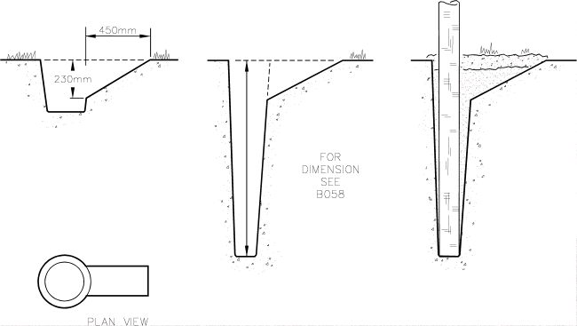

## Stepped Holes

Holes for any pole larger than 7L, where the pole is to be erected by a manual lift, or by the use of stout wooden ladders, should be stepped holes.

A stepped hole makes the initial lift of the pole easier.

Leave undisturbed earth against the pole in the direction of the stress produced by the line wires or cable.

Disturb as little ground as possible particularly for terminal poles, holes should be dug with the steps at right angles to the line of route wherever possible (see Figure 19).

Figure 19: Stepped Hole

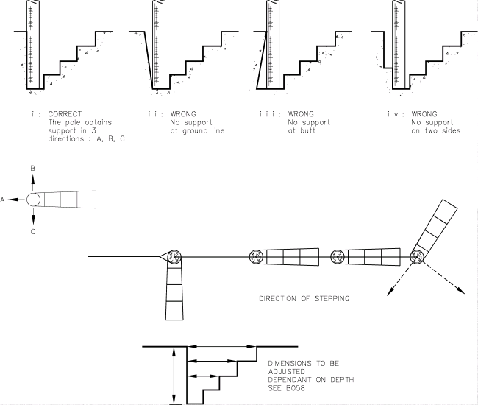

# Erecting the Pole

## Manpower

In deciding upon the manpower required for erecting poles the safety of personnel and of the public must have first consideration.

Conditions for the erection of poles vary considerably depending upon the position, accessibility and character of the site, proximity and class of highway, whether the poles have to be entirely manhandled, equipment available, weather conditions, and experience of the people employed. It is therefore impracticable to lay down a hard and fast rule as to the number of people required for the erection of each size of pole under all conditions. The person in charge of the team should ensure that a risk Assessment is carried out following the assessment in Appendix A.

Each job should be dealt with on its merits, and special consideration should be given to erection where conditions necessitate the assistance of additional team members and/or guidance from the Line Manager.

## Equipment

The equipment to be used for each method is outlined in the appropriate section below.

Take care to ensure that all equipment is in sound condition, has been examined as necessary and is of adequate strength for the work in hand.

ROPE - may be used as a guy line or a control/support line e.g. in assisting in raising a pole (particularly in replacement work). Rope may also be used for twisting poles of medium weight. Suggested ropes are shown in Table 1.

You must always check the condition of the rope before use. Look for any significant damage. Examine the rope in 300mm sections looking right round the rope; look particularly for:

1. External Wear - look for flattened strands and severed outer yarns. Compare with new rope.
2. Local Abrasion - can cause serious strength loss. If damage extends along the rope every outer yarn may be damaged or cut.
3. Cuts, etc - may cause internal as well as external damage. Look for local rupturing or loosening.
4. Internal Wear - look for excessive looseness of the strands and yarns and the presence of powered fibre.
5. Overloading - if you think a rope has been overloaded discard it. Obvious signs of very severe overloading are hardening of the rope, reduction in diameter, and considerably reduced extension under load.
6. Chemical Attack - may be revealed by staining, ease of plucking or rubbing off filaments or fibres from the yarns.
7. Attack by Heat - look for glazing of the rope surface or fusing of the fibres. Results in considerable loss in strength. Check for this particularly at points where rope to rope friction has occurred (e.g. pole lowering).  
   If a rope is at all suspect, discard it and use a new length.  
   Ropes used for any form of lifting must not have knots except at the end.  
   Where rope on rope friction will occur, movement should be kept slow e.g. lowering a pole.

|  |  |  |  |  |  |  |
| --- | --- | --- | --- | --- | --- | --- |
| Rope | Construction | Break-ing Load | Break­ing load with knots  2:1 factor | Safe Working Load no knots, i.e. 6:1 Safety Factor | Safe Working Load with knots, i.e. 12:1 Safety Factor | Recommended Use/Notes |
| Line Sash 15 | 8mm polypropylene | 650kg | 162kg | 108kg | 54kg | General purpose line |
| Rope 14mm, replaces Rope Sisal Prepared | 3 strand 100% staple spun polypropylene. Locally purchased. | 2790kg | 1395kg | 465kg | 232kg | Easy to grip |
| Rope 16mm As above | As above | 3500kg | 1750kg | 583kg | 291kg | Easy to grip |
| Rope 24mm As above | As above | 7600kg | 3800kg | 1266kg | 633kg | Easy to grip |
| Rope Cabling No 1 | 10mm pre-stretched polyester | 1590kg | 397kg | 265kg | 132kg |  |

Table 1 Suggested Ropes

## Pole Hole Preparation

Prepare the hole by placing a sliding face to guide the butt of the pole down the hole and prevent it digging into the side of the hole (see Figure 20).

Figure 20: Pole Prepared for Erection

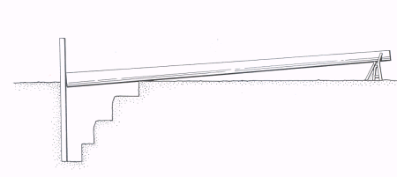

For cylindrical holes, place two digging bars against the side of the hole opposite that from which the channel has been cut to receive the butt of the pole.

For stepped holes use a sliding board.

During pole erection with a manual lift or ladders there should never be less than four people total and never less than two at the pole.

Always use a stepped hole except for Light poles up to 7 metres or hollow poles.

The people on the pole have the job of keeping it steady laterally.

## Methods Used

Rigid rules cannot be applied for sizes of poles to be erected by the various methods. The position of the pole should be considered. However, the following guidelines are suggested.

### The hierarchy for wooden poles:

1. The preferred method for installation is always to use a Pole Erection Unit where possible. See ISIS EPT/OHP/B034.
2. The second preference for Light and Medium poles up to 10m is to use Sheerlegs. Alternative models of sheerlegs may have a higher capacity, up to 12m poles, check the manufacturer’s specifications.
3. Poles up to 9m Light can be erected by a straightforward manual lift.
4. The final method, for poles up to 13 metres, is to use stout wooden ladders. This is the last option, and all other methods, including network redesign, to avoid the need for poles of this size, should be considered first.

### Hollow Poles:

All of the older stainless steel hollow poles can be erected by hand. The current galvanised steel hollow poles now come in two gauges, Light & Medium. Only the Light gauge galvanised steel poles can be erected by hand. Medium gauge poles must be erected by Pole Erection Unit or by use of Sheer Legs.

### Method 1 - Use of Sheerlegs

#### General

Sheerlegs are a mechanical device suitable for the manual erection of poles up to and including 10m. They consist of two light, metal, tubular legs to which are attached pulley blocks and tackle giving a mechanical advantage of 4:1. The tackle is attached to a winch mounted on one leg. The winch is operated by a cranked handle.

#### Working Method

(a) The butt of the pole is positioned over the hole and pushed up against the board/bars.

(b) The sheerlegs are laid along the pole with the apex at the butt end (one leg each side) and with each foot about 1.5m (5ft) from the pole (see Figure 21).

Figure 21: Sheerlegs (1)

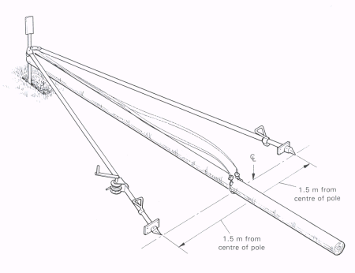

(c) Fit the chain on the pole at a point on the line between the feet of the sheerlegs. If this is not done it will be difficult to keep the sheerlegs upright when raising the pole. A good clearance between the pulleys and the rope and pole is necessary to avoid jamming (see Figure 22).

Figure 22: Sheerlegs (2)

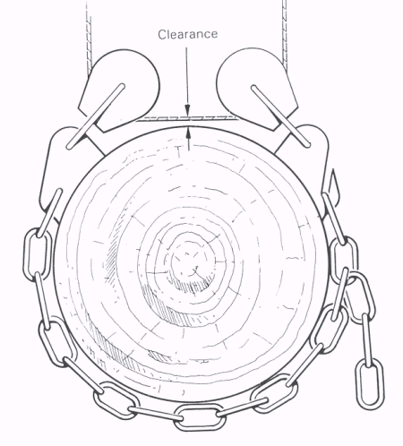

(d) Attachment to the pole should be such as to make the pole butt heavy.

(e) Raise the sheerlegs to the vertical. Ensure that the feet are firmly based and will not slip as the pole is raised and as the sheerlegs lean from the vertical.

(f) Raise the pole by operating the winch and the sheerlegs will finally become self-supporting due to the weight of the pole on the wire rope. As the pole is raised further, the sheerlegs will lean towards the pole hole. When the top of the pole is high enough, the butt will slide gently into the hole (see Figure 23).

Figure: 23 Sheerlegs (3)

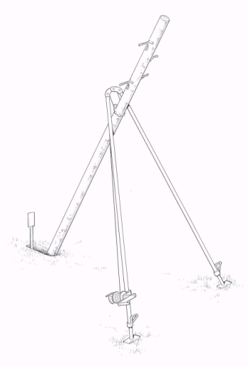

(g) When the wire rope is as high as possible, slide the legs of the sheerlegs towards the hole, maintaining their distance between each other, until the butt of the pole sinks to the bottom of the pole hole. 1 or 2 men may be required on each leg, depending on the size of the pole. Always keep the legs on the ground and slide them along (see Figure 24).

Figure 24: Sheerlegs (4)

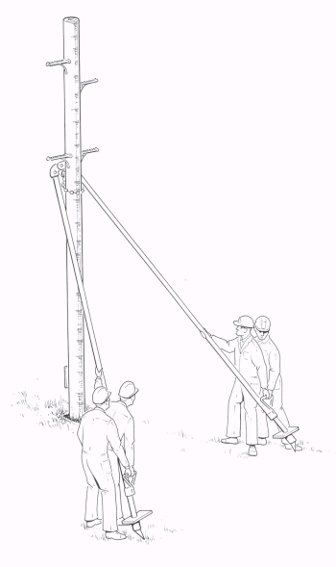

(h) Use the sheerlegs to hold the pole firmly in the required position during backfilling.

When the pole has been consolidated, slacken off the winch and lower the sheerlegs to the ground. The chain on the pole should loosen itself and slide down to allow removal.

### Method 2 - Hollow Poles and Wooden Poles up to 9 metre Light or 7 metre Medium

#### General Notes

1. Maximum pole size permitted is 9L or 7M. The average weight of a 9L is 140kgs, the average weight of a 7M is 135kgs.
2. A team of 4 is required for the task of manually lifting any pole up to 9L or 7M.
3. The Line Manager is responsible for ensuring that all team members have been briefed about the nature of the task, and that heavy physical effort is required.

#### Working Method

1. One person to assume control throughout the activity, to ensure a co-ordinated effort. In all lifting/manual handling, use the instructions 3…2…1...lift, lifting on the call of ‘lift’. The person in control should start the count, BUT all team members should join in to co-ordinate the effort.
2. Suitable PPE must be worn. Coverall, high-vis jacket/jerkin, helmets, boots and gloves leather.
3. Unload the pole from the vehicle, and carry/move the undressed pole to a suitable site.
4. Set the pole on the pole horse and dress in accordance with normal spec.
5. Dig pole hole to correct depth and dimension, and step the hole at 45º in the direction in which the pole will be installed. Ensure all safe digging rules are followed. (See Figure 20 in Section 4.4.)
6. Place two digging bars or other suitable slider in the pole hole, opposite the stepping. These are to prevent the butt of the pole jamming into the edge of the hole, and to assist in the butt of the pole sliding down into the hole.
7. Bring the pole into position, and rest on the ground, with the butt resting against the slider bars.
8. The person in control arranges the team, smallest person at the front. All people to stand on the same side of the pole.
9. On the command “. 3..2..1..lift”, lift the pole. The two central team members remain standing and should get the pole to the shoulder, and the team member behind should be reaching up, to support the pole. The front person should also support the pole on the shoulder, but with knees bent and back straight
10. Once the pole is steadied, the command “3…2…1…lift” should be given again, and on “lift” the pole should be pushed upright. As the pole rises, the individuals should move down the length of the pole to gain additional purchase and continue to push until upright. Once in position, the bars or slider should be removed. The pole should be turned to the correct orientation using a bar and rope if necessary. Two people should steady the pole while the hole is backfilled and firmly ‘punned’ in.
11. A single 3.5m stout wooden ladder may be used to assist the erection of hollow and very light wood poles if required.

Figure 25: Hollow or Wooden Pole (up to 9L or 7M) Manual Erection

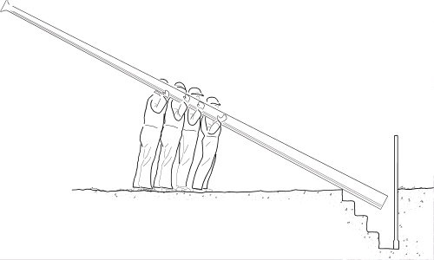

### Method 3 - Using Stout Ladders

#### General Principles

1. Only use stout wooden ladders with wire rungs at both ends (wooden ladders will give slightly under weight where as aluminium ladders will bend and buckle). Two ladders are required, one 3.5m and one 4.5m.
2. The bases of the ladders should always be in contact with the ground when pushing the pole up, that is slide the foot of the ladder along the ground.
3. The people on the ladders walk forward using the ladders to push the pole up using the increased leverage whilst the other people push the pole up from lower down.
4. Never push both the ladders past 90° as there could be a tendency for them to slide up the pole and one must always be capable of taking the weight.
5. All instructions must be given by the person at the rear.
6. A foot must always be placed behind the ladder to prevent them slipping.
7. Once the pole is being lifted always ensure there is a ‘safe side’ and that everybody understands to move towards the safe side and push the pole away from the safe side in the event an incident during erection. As much as possible everyone should operate on the safe side - where someone does not then a clear escape route should be identified in the case of an incident (for example forward past the pole hole).
8. During pole erection with ladders there should never be less than four people in total.
9. The person on the pole has the job of keeping it steady laterally.

#### Working Method

1. Place the pole butt against the pole sliding board or digging bars, and stand the tip on the horse pole. The pole steps should be parallel to the ground, to avoid them interfering with the ladders.

2. Two Lines Sash No 15 are tied at the top of the pole (one 1m from the tip the other 1m below). The two ladders laid on the ground in line with the pole but to one side (top of ladders pointing towards the hole) and the sashline passed between the wire rung and the top wooden rung, down the back and out under the fourth rung.

3. The rope from the shorter ladder should be laid out toward the pole, and the rope from the longer ladder should be laid out away from the pole (see Figure 26). Consideration should be given to having ropes reserved only for this task, and cut to the minimum required length, but allowance will need to be made for varying length of pole. This is to avoid having excess surplus rope on the floor at the worksite.

4. The tip of the pole is lifted as in Section 2.3.1.3 (the horse pole should be removed) until it is high enough to allow the short ladder to be inserted at an angle of 90°.

5. One person drops out and places the short ladder at 90° to the pole, pulling the sashline tight and wrapping it around a rung (see Figure 27). The foot of the ladder is placed on the ground and the pole weight is then supported by the short ladder.

Figure 26: Ladders Laid Out on Ground

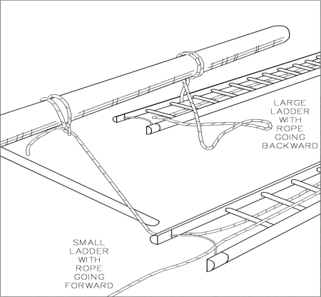

Figure 27: First Ladder in Position

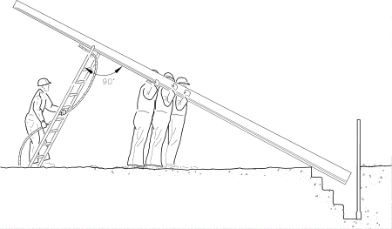

6. Two people position the long ladder in the same way as the short ladder, but at an angle greater than 90° to the pole (see Figure 28).

Figure 28: Two Ladders in Use

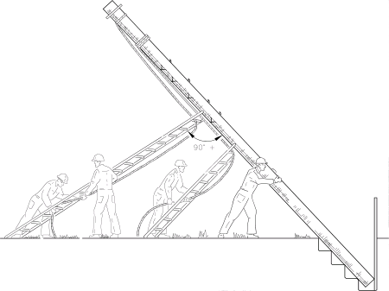

7. The person in charge should be on the back of the ladder, taking control and giving the commands of push and rest. The men remaining on the pole have the job of keeping it steady. Under no circumstances should the ladders be lifted off the ground, slide the base along the ground.

8. Every time the long ladder reaches 90° the command of rest is given and the short ladder repositioned at 90° so that it can support the pole while the long ladder is repositioned to greater than 90° ready for the next push (see Figure 29).

Figure 29: Repositioning Ladders

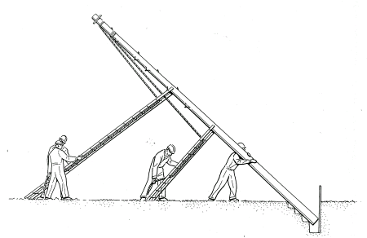

9. The operation is repeated until the pole is in position.

10. Two people steady the pole using the ladders whilst it is consolidated enough to be stable. Ensure that the ropes are tied off to ensure that the ladders cannot fall on those filling in.

11. For heavy poles use more people on each ladder.

1. The long ladder should never be pushed passed 90° . This is to ensure that the ladder does not slide up the pole (the sashlines ensure that the ladders do not slide down the pole).

# After Pole Erection

## Supporting Pole after Erection

(a) After the pole has been erected and during filling in, it should be supported in an upright position by one or more men depending on the size of the pole or by guy lines previously attached to the pole or by ladders, lifters or sheerlegs.

(b) Always ensure that the method of support is adequate to avoid strain or injury of anyone left supporting a pole.

(c) Always use guy lines or sheerlegs on a pole in a stepped hole.

## Pole Orientation

Ideally set the pole at the correct orientation as it is erected. If this cannot be done twist the pole. A small amount of backfill can help to stabilise the pole during this operation.

### Wooden Poles

Full details of pole positioning and orientation are covered in EPT/ANS/A010.

### Hollow Poles

Full details of pole positioning and orientation are covered in EPT/ANS/A010.

## Twisting

### General Notes

1. Always ensure that the pole is stable before twisting.
2. Twist hollow poles by hand.

### Twisting Poles

For wooden poles use a Twister Pole or a length of rope with a crowbar or other suitable lever. Double the rope back on itself and give the bite thus formed two or three turns round the pole in the direction in which it is to be twisted (see Figure 30). Position the loop conveniently for the use of the lever. Pass the end of the lever through the loop and as the pole is twisted hold the rope at the other side to prevent slip.

For heavy poles always use a Twister Pole (see Figure 31).

For hollow poles use rope method with piece of wood, or pull round by hand if possible. Always wear gloves if pulling on the door aperture.

Figure 30: Twisting with Rope

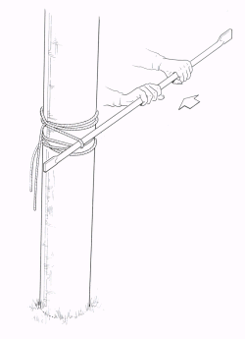

Figure 31: Twister Pole

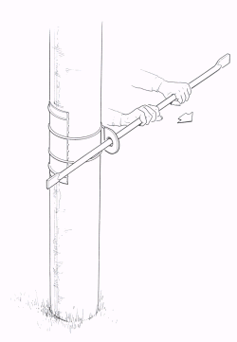

## Setting the Pole

Alignment is of particular importance in built-up areas and further details can be found in EPT/ANS/A010. The appearance of a line depends largely on the care taken in the setting and alignment of the poles.

1. In straight sections of line, set the poles in a vertical position.
2. At terminal points and angles in the line, it is advisable to set poles so as to bear slightly against the stress of the cables to allow for consolidation of the disturbed soil, which only slowly regains its original solidity. This inclination should only be sufficient to allow the pole to attain a vertical position when it is fully loaded and all settlement has ceased.
3. In built-up areas assist pole setting by comparison with the profile of the wall of a building.
4. Ensure that poles set on gradients are not inclined downhill.
5. In setting a pole which is to be stayed on one side only, for example terminal and angle poles, make allowance for the fitting of the stay(s), which, when tightened initially, that is prior to the erection of the wires, will tend to increase the set. The fitting of the stay to a pole set vertically will often provide all the set required, particularly where the line will be only partly cabled during the critical period of settlement of the soil.
6. If a line of poles is being installed, try to ensure that all the poles are aligned. A line of poles all at slightly differing angles does not enhance BT’s image.
7. Remember DP's should be set at least 300mm deeper. If it is clear that the DP will be loaded on one side only, stays should be fitted where possible. If neither of the above are possible set the pole slightly against the anticipated load.

## Backfilling

Reinstatement and backfilling should be in accordance with ISIS EPT/UGP/B053.

1. Before backfilling check that the pole is at the correct depth and that maximum distance between the 3m mark and the lowest point of the ground around the pole will be less than 1.8m unless local arrangements for poles in rock are in place.
2. If any stones were removed during excavation, pack and ram them tightly at the foot of the hole, and also near the top to provide an extended bearing surface.
3. Backfill is placed and adequately compacted in maximum 100 mm layers using Punner Curved for poling (Item code 129472).
4. Wedge rock tightly around poles set in rock.

## Filling Cylindrical Holes

Where a number of poles in line are being erected in cylindrical holes, if possible fill them in to a depth of 300mm as they are erected. This will ensure the stability of the poles until they are finally aligned, when the filling-in operations can be completed. (Never climb poles until final reinstatement is complete.)

## Hollow Pole Sealing

Where the cable to a hollow pole is directly buried for a least 1m from the hollow pole no sealing is necessary.

If a duct is led to a hollow pole (duct 56 or 102), lead the duct into the base of the pole sealing the other end of the duct at the nearest box in accordance with EPT/UGP/B033 Duct, Description, Repair and Sealing. A duct to a hollow pole should be led through the cable holes and cut off at approximately 100mm above ground level.

# Method for Dealing with Leaning Poles

INTRODUCTION:

There are several reasons why a pole begins to lean after installation, including, ground conditions, pole depth, pull on pole and quality of reinstatement. A leaning pole is reported as a defect via the A1024 system (ARTISAN). Currently, the A1024s are recorded with a defect code of 502 (pole fittings) and given a remedy code of 324 (provide stay). The method of reporting a leaning pole is documented in the leaning poles process from the link on the [pole test home page](http://netactive.intra.bt.com/communities/ndandi/assetassurance/poletest.htm) .

PROCESS:

All overhead plant (loading) should be removed from the pole to ensure safe working practices are followed. The pole should be lifted/jacked out of the ground using the documented process detailed in EPT/OHP/B034 section 6 The revised planting depths detailed in EPT/OHP/B058 section 3.2 must be achieved to ensure pole stability in poor soil/ground conditions (one of the main causes of the problem). The pole is then re-planted using appropriate backfill material for the ground conditions detailed in EPT/UGP/B053.

On completion of the work, the pole should be of sufficient height to meet the new dropwire & aerial cable install/replace heights as detailed in EPT/ANS/A013 If, prior to work commencing, the use of the existing pole, planted at the depth detailed in EPT/OHP/B058, would be deemed to compromise the new dropwire & aerial cable install/replace heights as detailed in EPT/ANS/A013 then a DFE from the programme office may be sought to replace the pole with a new larger pole.

Wood Poles Fit for Re-issue

Poles that have been recovered may be considered fit for re-use if they meet the criterion detailed in ISIS EPT/OHP/B058.

# Tools and Equipment Lists

| Item | Item Code | Notes | Supplier |
| --- | --- | --- | --- |
| Bar Digging | 110400 |  |  |
| Bar Operating Large | 110402 |  |  |
| Brace Coach Screw | 112089 |  |  |
| Brooms, Bass | Local Purchase | Ref. 342506 & 342513 | Buck and Hickman Tel: 0114 2766660 |
| Caps Pole 1A | 016277 |  |  |
| Collar Hollow Pole 1 | 016317 |  |  |
| Collar Hollow Pole 2 | 016318 |  |  |
| Crowbars No 2 | 112871 |  |  |
| Digging Bar GRP | 129473 |  |  |
| Drawrope No 1 | 071830 |  |  |
| Extension Shaft GRP | 129474 |  |  |
| Hessian | Local Purchase | Untreated Hessian Cloth 36" Wide | Phillip Stamp & Co Ltd Unit 2 Tollemache Business Park Offton, Ipswich Suffolk IP8 4RT  Tel - 01473 657770  E-Mail [sales@philipstamp.co.uk](mailto:sales@philipstamp.co.uk) |
| Horse Pole | 126681 |  |  |
| Line Sash 2 | 115225 |  |  |
| Line Sash 15 | 126558 |  |  |
| Hollow Pole Numbering Labels | Local Purchase | A52058/0 to 9 | Critchley Label Centre, Crumlin, Gwent,  Tel 01495 244000 Fax 01495 272527 |
| Hollow Pole Climbing Prohibition labels | Local Purchase | A220480 | Critchley Label Centre, Crumlin, Gwent,  Tel 01495 244000 Fax 01495 272527 |
| Pole Timber Grab Hand Type | 123476 |  |  |
| Punner Curved | 129472 |  |  |
| Punners Iron | 115975 |  |  |
| Punners Wood | 115977 |  |  |
| Rope 12mm 220m max loading | Local Purchase |  | Marlow Ropes Ltd HAILSHAM 01323 847234  or  Bridon Fibers Ltd. Charlton, LONDON 0181 858 6121 |
| Rope 16mm 220m 810kg | Local Purchase | As above |  |
| Rope 24mm 220m 1830 kg | Local Purchase | As above |  |
| Sheerlegs | Local Purchase | Sheerlegs Type Size 6 m legs | Ritelite Ltd  Stamford, Lincs  01780 765600 |
| Shovels, Gravel No 3 | 116466 |  |  |
| Sliding Board | Made up locally |  |  |
| Socket Tool Wire Stringing | 116521 |  |  |
| Spade Rabbiting | 116543 |  |  |
| Spade Rabbiting GRP | 129492 |  |  |
| Spoon Excavating GRP | 129471 |  |  |
| Stout Ladders | Local Purchase | 2 ladders reqd  1 x 3.5 metre  1 x 4.5 metre  both with wound-wire top rung | Purchase from current BT wood ladder supplier. Contact BT Supply Chain Solutions |
| Strap Tensioning 1A, 3m | 126760 |  |  |
| Strap Tensioning 2A, 9m | 126761 |  |  |
| Tensioner 3A | 126762 |  |  |
| Trucks Pole Carrying | 122505 |  |  |
| Twister Pole | 127112 |  |  |

# References

1. [Health and Safety Handbook](http://humanresources.intra.bt.com/safety-handbook/contents/11847)
2. EPT/ANS/A010 Specification for Poling
3. EPT/OHP/B033 Poling Handbook - Index
4. EPT/OHP/B034 Poling Handbook - Mechanised Poling Practices
5. EPT/OHP/B036 Poling Handbook - Pole Fittings and General Furniture
6. EPT/OHP/B053 Pole Test/Examination Excavation & Reinstatement
7. EPT/OHP/B058 Poles, Planning Information
8. EPT/PPS/B026 Code of Practice
9. EPT/PPS/B046 Work on Overhead BT Lines in the Vicinity of Power Lines
10. EPT/UGP/B033 Duct, Description, Repair and Sealing.
11. EPT/UGP/B053 Pole Test/Examination Excavation and Reinstatement
12. MTT/VHE/E001 Commercial Vehicle Drivers Handbook
13. [CGA/N207](http://documents.intra.bt.com:83/edrsbks/i_sfyhsh/books/1hshc009/extfile/cgan207.doc) Handling and Examination of Creosoted Pole (in SFY/HSH/C009)
14. SFY/HSH/D011 Personal Protective Equipment
15. SFY/HSH/D057 Safe Digging and Location of Buried Services
16. SFY/GRA/A005 GRA - Handing & Erection of a BT Pole
17. SFY/GRA/A012 GRA - Manual Loading of Poles onto BT Vehicles

# Risk Assessment

The following Risk Assessment (SFY/GRA/A005) should be used to assess the likely hazards that may be encountered during manual poling, and the measures that should be taken to reduce hazards where appropriate.

[Click Here](http://documents.intra.bt.com/bookstore/isis/sfy/i_sfygra/1graa005/) to link to Risk Assessment

END OF DOCUMENT